**CSA1597:-COLUD COMPUTING AND BIG DATA**

**DAY 1 LAB**

**NAME:-D.TAKESHBABU**

**REGNO:-192125027**

**1.CREATE A SIMPLE CLOUD SOFTWARE APPLICATION AND PROVIDE IT AS A SERVICE USING ANY CLOUD SERVICE PROVIDER TO DEMONSTRATE SOFTWARE AS A SERVICE (SAAS).**

AIM:

# To create a simple cloud software application and provide it as a service using it as a service using any cloud service provider to demonstrate Software as a Service (SAAS).

PROCEDURE:

# STEP1: GOTO ZOHO.COM

STEP 2: LOGIN TO THE ZOHO.COM

STEP 3: SELECT ONE APPLICATION

STEP 4: ENTER APPLICATION NAME

STEP 5: CREATE A NEW APPLICATION

STEP 6: SELECT ONE FORM

# STEP 7: THE SOFTWARE HASE BEEN CREATED.

IMPLEMENTATION:

STEP1: GOTO ZOHO.COM



STEP 2: LOGIN TO THE ZOHO.COM



STEP 3: SELECT ONE APPLICATION

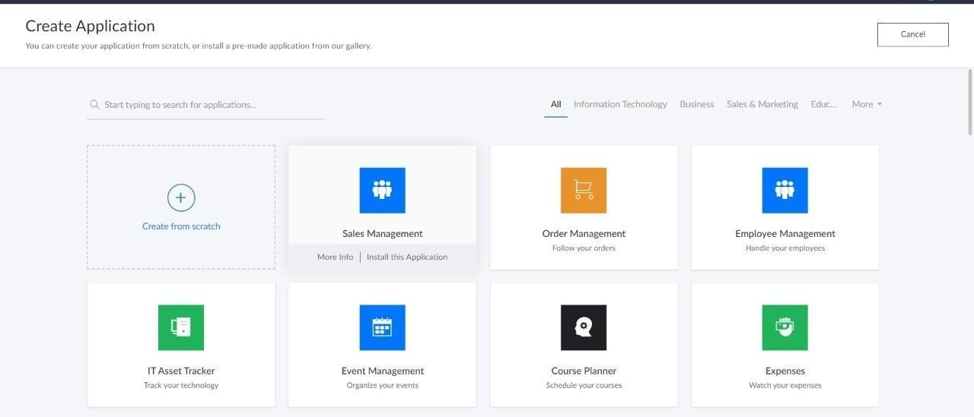

STEP 4: ENTER APPLICATION NAME

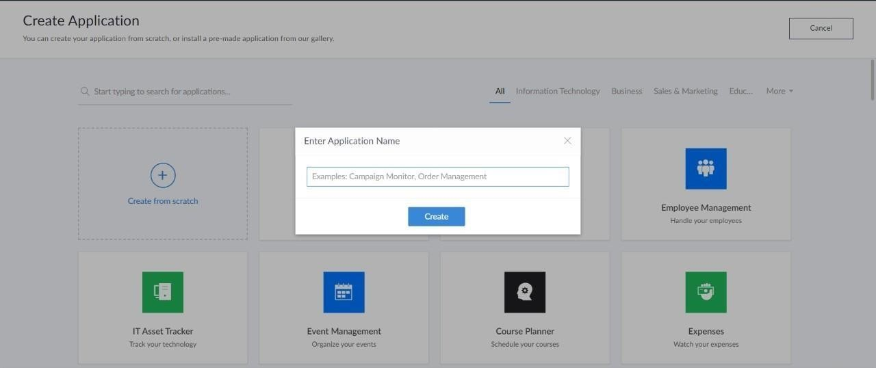

STEP 5: CREATED NEW APPLICATION

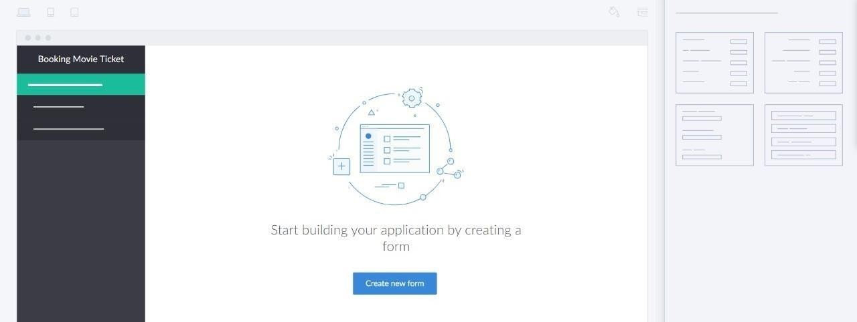

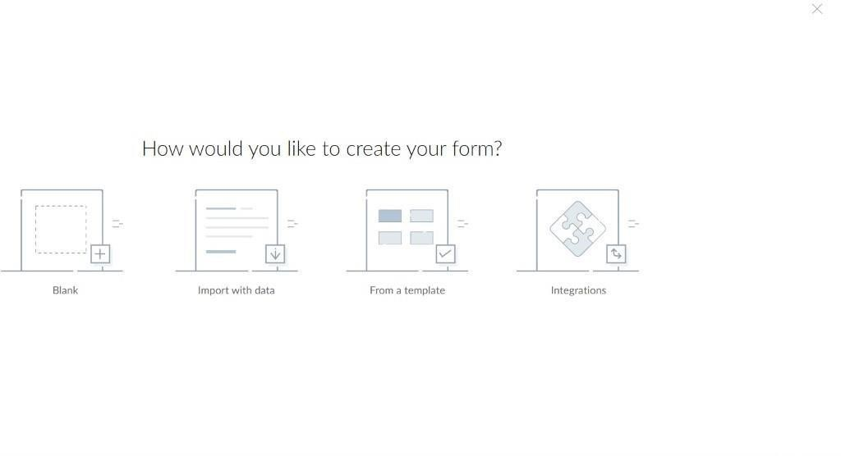STEP 6: SELECT ONE FORM

STEP 7: THE SOFTWARE HASE BEEN CREATED.

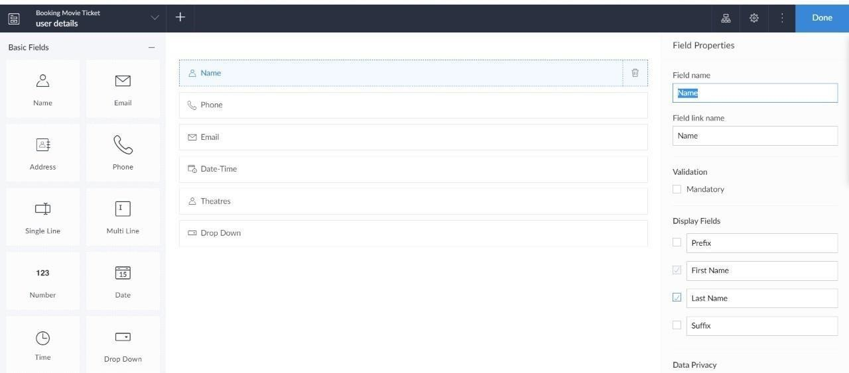

OUTPUT:

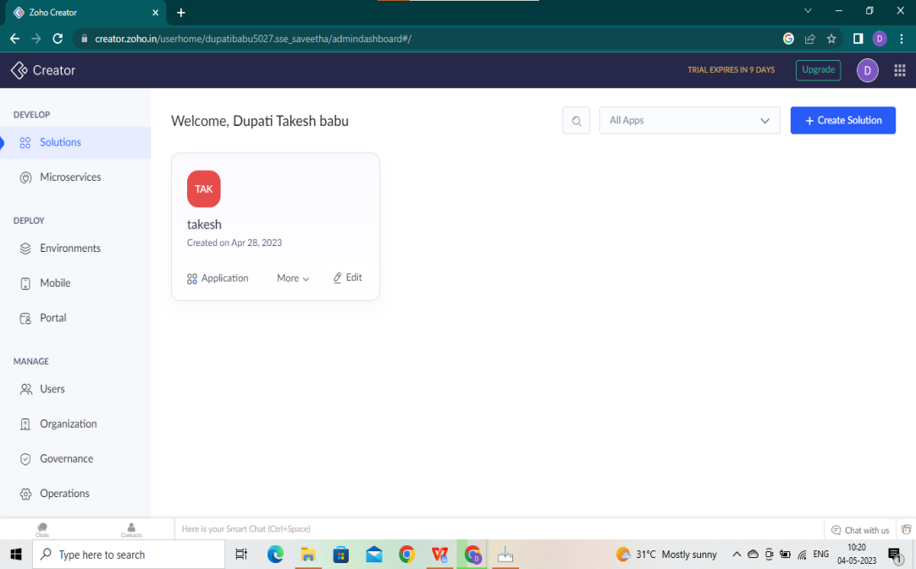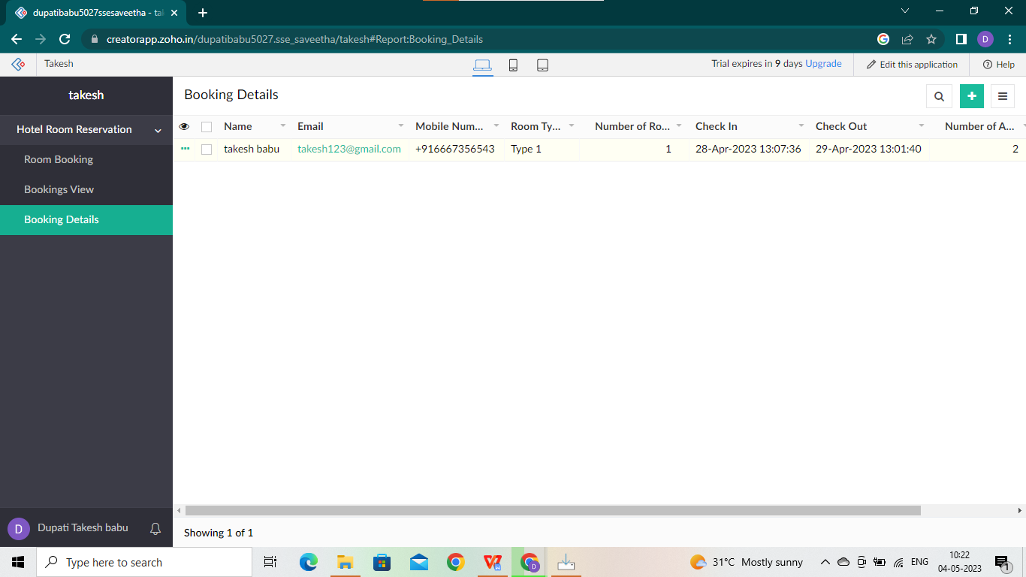

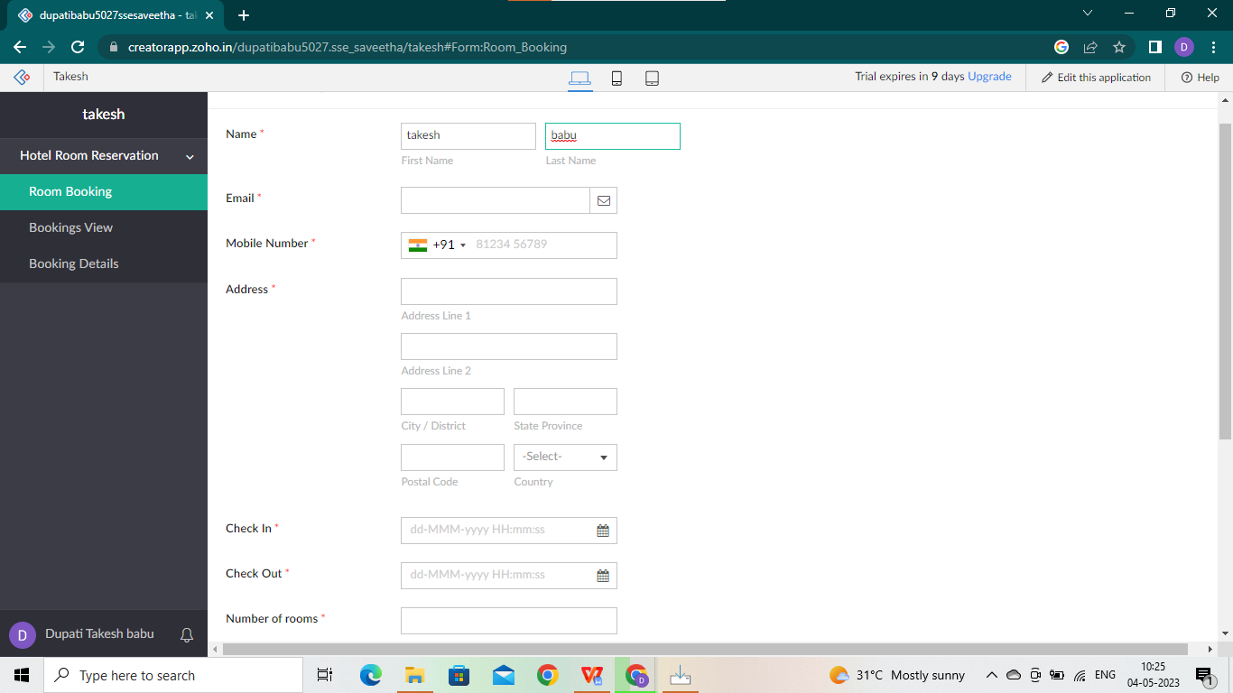

**RESULT:**

Hence The Creation of a CREATE A SIMPLE CLOUD SOFTWARE APPLICATION AND PROVIDE IT AS A SERVICE USING ANY CLOUD SERVICE PROVIDER TO DEMONSTRATE SOFTWARE AS A SERVICE is performed sucessfully

# **2.CREATE A VIRTUAL MACHINE WITH 1 VCPU, 2GB RAM AND 15GB STORAGE DISK USING A TYPE VIRTUALIZATION SOFTWARE**

**AIM:**

To create a virtual machine with 1 CPU, 2gb ram and 15gb storage disk using a type 2 virtualization software

# PROCEDURE:

1. Download VMware workstation and installed as type 2 hypervisor
2. Download Ubuntu or tiny os as iso image file 3. In VMware workstation->create new VM 4. Do the basic configuration settings.
3. Created tiny OS virtual machine
4. Launch the VM

# IMPLEMENTATION:

**STEP 1:**

# DOWLOAD VMWARE WORKSTATION AND INSTALLED AS TYPE 2 HYPERVISOR

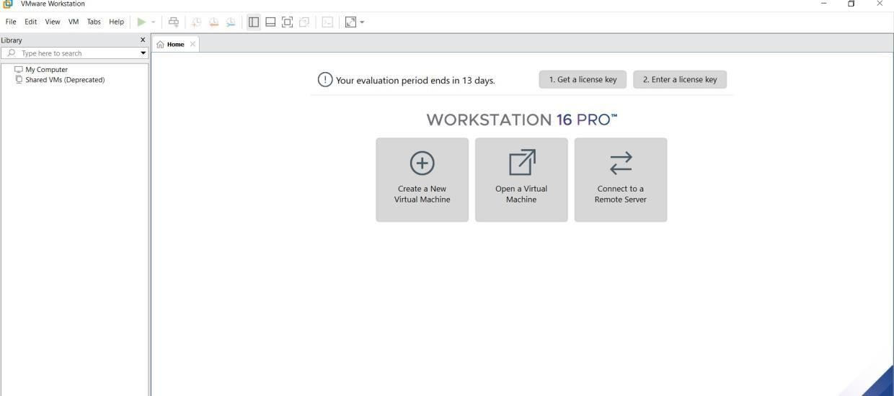

**STEP2: DOWLOAD UBUNTU OR TINY OS AS ISO IMAGE FILE**

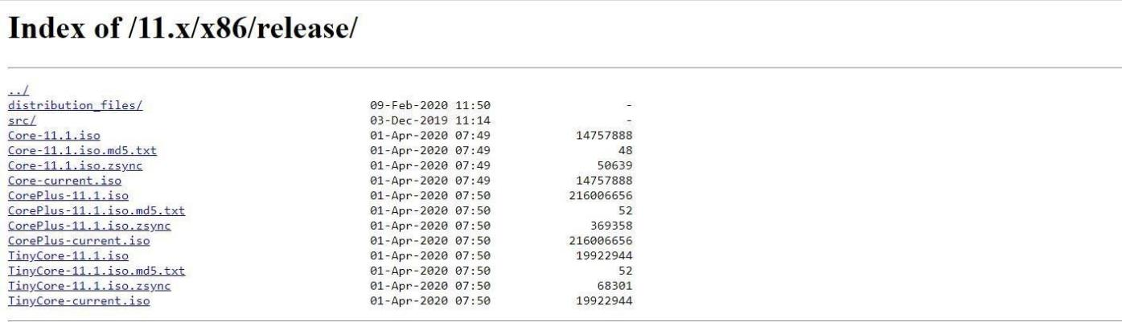

# STEP 3: IN VMWARE WORKSTATION->CREATE NEW VM



**STEP 4: DO THE BASIC CONFIGURATION SETTINGS.**

